
Sec: LT-IIT-N120 Date: 01-10-2022
Time: 3hrs (WTA-1) Max. Marks: 180
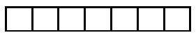
Name of the Student: ___________________ H.T. NO:

JEE-ADVANCE-2018-P1-Model
Important instructions
PHYSICS:
Section | Question Type | +Ve  Marks | - Ve  Marks | No.of Qs | Total marks
Sec – I(Q.N : 1 – 6) | Questions with Multiple Correct Choice  (partial marking scheme) (+1,0) | +4 | -2 | 6 | 24
Sec – II(Q.N : 7 – 14) | Questions with Numerical Value Type  (e.g. 6.25, 7.00, ‐0.33, ‐.30, 30.27, ‐127.30) | +3 | 0 | 8 | 24
Sec – III(Q.N :15-18) | Questions with Comprehension Type  (2 Comprehensions – 2 +2 = 4Q) | +3 | -1 | 4 | 12
Total |  |  |  | 18 | 60
CHEMISTRY:
Section | Question Type | +Ve  Marks | - Ve  Marks | No.of Qs | Total marks
Sec – I(Q.N : 19–24) | Questions with Multiple Correct Choice  (partial marking scheme) (+1,0) | +4 | -2 | 6 | 24
Sec – II(Q.N : 25–32) | Questions with Numerical Value Type  (e.g. 6.25, 7.00, ‐0.33, ‐.30, 30.27, ‐127.30) | +3 | 0 | 8 | 24
Sec – III(Q.N :33-36) | Questions with Comprehension Type  (2 Comprehensions – 2 +2 = 4Q) | +3 | -1 | 4 | 12
Total |  |  |  | 18 | 60
MATHS:
Section | Question Type | +Ve  Marks | - Ve  Marks | No.of Qs | Total marks
Sec – I(Q.N : 37–42) | Questions with Multiple Correct Choice  (partial marking scheme) (+1,0) | +4 | -2 | 6 | 24
Sec – II(Q.N : 43–50) | Questions with Numerical Value Type  (e.g. 6.25, 7.00, ‐0.33, ‐.30, 30.27, ‐127.30) | +3 | 0 | 8 | 24
Sec – III(Q.N :51-54) | Questions with Comprehension Type  (2 Comprehensions – 2 +2 = 4Q) | +3 | -1 | 4 | 12
Total |  |  |  | 18 | 60

PHYSICS Max.Marks: 60
SECTION- I
(Maximum Marks : 24)
This section contains SIX (06) questions.
Each question has FOUR options for correct answer(s). ONE OR MORE THAN ONE of these four option(s) is (are) correct option(s).
For each question, choose the correct option(s) to answer the question.
Answer to each question will be evaluated according to the following marking scheme:
Full Marks : +4 If only (all) the correct option(s) is (are) chosen.
Partial Marks: +3 If all the four options are correct but ONLY three options are chosen.
Partial Marks: +2 If three or more options are correct but ONLY two options are chosen, both of which are correct options.
Partial Marks : +1 If two or more options are correct but ONLY one option is chosen and it is a correct option.
Zero Marks : 0 If none of the options is chosen (i.e. the question is unanswered).
Negative Marks: -2 In all other cases.
1. A particle moving along a straight line with uniform acceleration has velocities 7 ms^{–1} at A and 17 ms^{–1} at C. B is the mid point of AC. Then,
A) the velocity at B is 12 ms^{–1}.
B) the average velocity between A and B is 10 ms^{–1}.
C) the ratio of the time to go from A to B to that from B to C is 3 : 2.
D) the average velocity between B and C is 15 ms^{–1}.
2. A ball is dropped from the top of a building. The ball takes 0.5 s to fall through the 3 m length of a window which is located some distance from the top of the building. If the velocities of the ball at the top and at the bottom of the window are v_{T} and v_{B} respectively, then (take g = 10 ms^{–2}):
A) 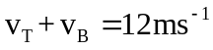 B) 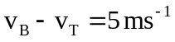 C) 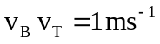 D) 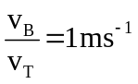
3. Drops of water fall from the roof of a tall building at regular intervals of time. A boy observes the falling drops. The distance between the first and the second drop is s₁ and that between the third and the fourth is s₂ at any time after the 4th drop begins to fall.
A) s₁ = s₂ before the first drop hits the ground
B) s₁ > s₂ before the first drop hits the ground
C) s₁ < s₂ before the first drop hits the ground
D) Nothing can be said unless we know the interval between the drops.
4. A particle moving along a straight line has initial velocity 10 ms^{–1}. It is acted by a constant force along the line of motion which produces an acceleration of 5 ms^{–2} opposite to the initial direction of motion of the particle. Then,
A) the maximum displacement in the direction of initial velocity is 10 m.
B) the distance travelled in first 3 seconds is 7.5 m.
C) the distance travelled in first 3 seconds is 12.5 m.
D) the distance travelled in first 3 seconds is 17.5 m.
5. If the resultant of three force 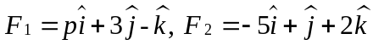and 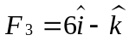acting on a particle has magnitude equal to 5 units, then the value (s) of p is (are)
A) -6 B) -4 C) 2 D) 4
6. For the situation shown below, which of the following results are correct?
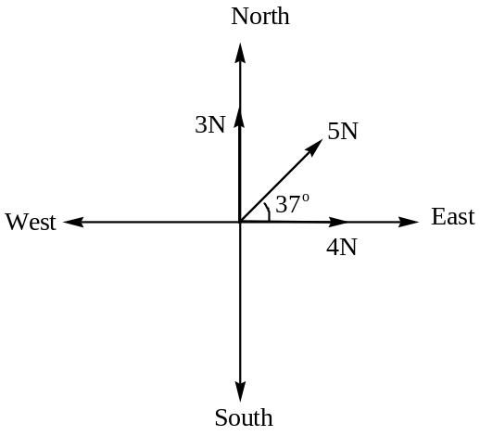
A) 6 N is the magnitude of minimum force that can be applied in any direction so that the resultant force is along the east direction.
B) 10 N is the magnitude of additional force that can be applied so that the resultant force is along east direction and has a magnitude 16 N.
C) 6 N is the magnitude of maximum force that can be applied in any direction so that the resultant force is along east direction.
D) 10 N is the magnitude of additional force that can be applied so that the resultant force is along east direction and has a magnitude 8 N.
SECTION - II
(Maximum Marks : 24)
This section contains EIGHT (08) questions. The answer to each question is a NUMERICAL VALUE
For each question, enter the correct numerical value (in decimal notation, truncated/rounded off to the second decimal place; e.g. 6.25, 7.00, -0.33, -.30, 30.27, -127.30) designated to enter the answer.
Answer to each question will be evaluated according to the following marking scheme:
Full Marks: +3 If ONLY the correct numerical value is entered as answer.
Zero Marks: 0 In all other cases.
7. A particle is moving along the x-axis. Its velocity is 10 ms^{–1} when it crosses the origin. It moves with a constant acceleration till its velocity becomes 50 ms^{–1}. At this point in time its acceleration reverses direction (though the magnitude remains constant) and stays constant thereafter. Find the speed of the particle when it returns to the origin.
8. A parachutist jumps from a hovering helicopter at a height H from ground. He falls 50 m without friction. At this point the parachute opens and he decelerates at a rate of 2 ms^{–2}. He reaches the ground with a speed of 3 ms^{–1}.
(i) For how long is the parachutist in air?
9. Two balls are shot upward one after the other at an interval of 2 second with an initial velocity of 39.2 ms^{–1} along the same vertical line. At what height will they collide?
[g = 9.8 ms^{–2}]
10. A uniformly accelerated train passes two successive kilometre marks while travelling at a velocity of 2 ms^{–1} and 10 ms^{–1}. Find the velocity of the train at the next kilometre mark if it still continues to accelerate.
11. If the position vector of the vertices of a triangle are 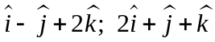 and 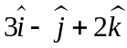 then find the area of the triangle.
12. The farm house shown in the figure below has a rectangular shape and has sides parallel to the chosen x and y axes. The position vector of corner A is 125 m at 53° and corner C is 100 m at 37° from x-axis. Find the length of the fencing required in metre.
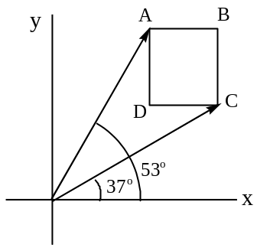
13. A sail boat sails 2 km due east, 5 km 37° south of east and finally an unknown displacement. If the total displacement of the boat from the starting point is 6 km due east, determine the third displacement. Given: sin 37° = 3/5
14. Forces X, Y and Z have magnitudes 10 N, 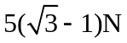and 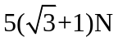. The forces Y and Z act in the same direction as shown in the diagram. The resultant of X and Y and the resultant of X and Z have the same magnitude. Find , the angle between X and Y.
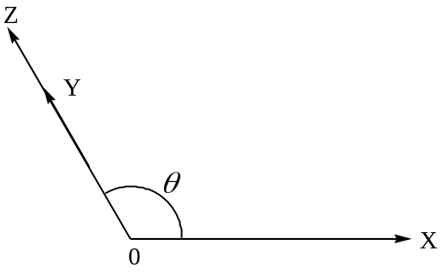
Section – III
(COMPREHENSIN TYPE)
This section contains 2Paragraphs. Based on each paragraph, there are 2 questions. Each question has 4 options (A), (B), (C) and (D) for its answer, out of which ONLY ONE option can be correct.
Marking scheme: +3 for correct answer, 0 if not attempted and -1 in all other cases.

Paragraph for Question Nos. 15 to 16:
A train starts from rest with constant acceleration, 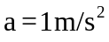. A passenger at a distance ‘S’ from the train runs at his maximum velocity of 10 m/s to catch the train at the same moment at which the train starts.
15. If S = 25.5 m and passenger keeps running, find the time in which he will catch the train:
A) 5 sec B) 4 sec C) 3 sec D) 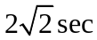
16. Find the critical distance ‘S_{c}’ for which passenger will take ten seconds time to catch the train:
A) 50 m B) 35 m C) 30 m D) 25 m
Paragraph for Question Nos. 17 to 18:
A body is moving with uniform velocity of 8 ms⁻¹. When the body just crossed another body, the second one starts and moves with uniform acceleration of 4 ms⁻².
17. The time after which two bodies meet will be
A) 2 s B) 4 s C) 6 s D) 8 s
18. The distance covered by the second body when they meet is
A) 8 m B) 16 m C) 24 m D) 32 m
CHEMISTRY Max.Marks: 60
SECTION- I
(Maximum Marks : 24)
This section contains SIX (06) questions.
Each question has FOUR options for correct answer(s). ONE OR MORE THAN ONE of these four option(s) is (are) correct option(s).
For each question, choose the correct option(s) to answer the question.
Answer to each question will be evaluated according to the following marking scheme:
Full Marks : +4 If only (all) the correct option(s) is (are) chosen.
Partial Marks: +3 If all the four options are correct but ONLY three options are chosen.
Partial Marks: +2 If three or more options are correct but ONLY two options are chosen, both of which are correct options.
Partial Marks : +1 If two or more options are correct but ONLY one option is chosen and it is a correct option.
Zero Marks : 0 If none of the options is chosen (i.e. the question is unanswered).
Negative Marks: -2 In all other cases.
19. 1 mole of Ba(OH)₂ will exactly neutralize:
A) 0.5 mole HCl B) 1 mole of H₂SO₄
C) 1 mole of H₃PO₃ D) 2 mole of H₃PO₂
20. Which of the following is/are correct for 17 g/L of H₂O₂ solution?
A) Volume strengths is 5.6 at 273 K and 1 atm
B) Molarity of solution is 0.5 M
C) 1 mL of this solution gives 2.8 mL O₂ at 273 K and 2 atm
D) The normality of solution is 2M
21. A sample of H₂O₂ solution labelled as “28 volume” has density of 265 g/L. Mark the correct option(s) representing concentration of same solution in other units:
A) 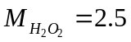 B) 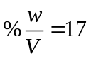
C) Mole fraction of 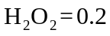 D) 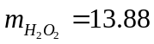
22. Select the correct statements:
A) factor for CrI₃ when it oxidises to 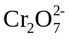and 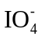is 27
B) factor for 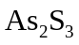when it oxidises to 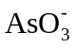and 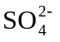is 28
C) factor for 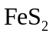when it is oxidized to 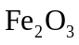and 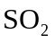is 11
D) factor for 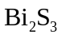when it is oxidized to 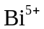and S is 10
23. 100 g P₄O₆ is treated with 100 g KMnO₄ in presence of HCl to from H₃PO₄ and MnCl₂, then:
A) KMnO₄ will act as limiting reagent B) factor for P₄O₆ is 4
C) factor of KMnO₄ is 5 D) P₄O₆ will act as limiting reagent
24. The ratio of the de Broglie wavelengths of a proton and particles will be 1: 2 if their:
A) velocity are in the ratio 1: 8 B) velocity are in the ration 8 : 1
C) kinetic energy are in the ratio 1: 64 D) kinetic energy are in the ratio 1: 256
SECTION - II
(Maximum Marks : 24)
This section contains EIGHT (08) questions. The answer to each question is a NUMERICAL VALUE
For each question, enter the correct numerical value (in decimal notation, truncated/rounded off to the second decimal place; e.g. 6.25, 7.00, -0.33, -.30, 30.27, -127.30) designated to enter the answer.
Answer to each question will be evaluated according to the following marking scheme:
Full Marks: +3 If ONLY the correct numerical value is entered as answer.
Zero Marks: 0 In all other cases.
25. A sample of 28 mL of 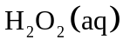solution required 10 mL of 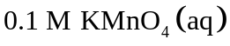solution for complete reaction in acidic medium. What is the volume strength of 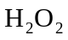?
26. 2.0 g of polybasic organic acid (Molecular wt. = 600) required 100 mL of 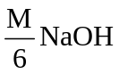solution for complete neutralization. Find the basicity of acid.
27. Number of peroxide bonds in 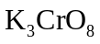
28. What mass of 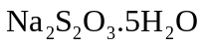is needed to make 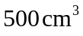of 0.200 N solution for the reaction 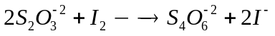
29. The value of in the molecular formula 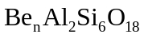is______________
30. The radiations obtained from deexcitation of H-atom from second orbit to 1st, striked on a metal of work function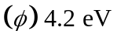. The wavelength (in 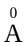) of ejected electron having maximum kinetic energy is:
31. If uncertainty in the position of anparticle is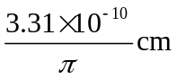. If minimum uncertainty in kinetic energy is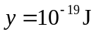, what is?
32. Suppose 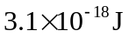energy is needed by the interior of the human eye to see an object. How many photons of light of 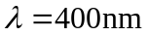will be needed to sec the object? 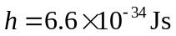.
Section – III
(COMPREHENSIN TYPE)
This section contains 2Paragraphs. Based on each paragraph, there are 2 questions. Each question has 4 options (A), (B), (C) and (D) for its answer, out of which ONLY ONE option can be correct.
Marking scheme: +3 for correct answer, 0 if not attempted and -1 in all other cases.

Paragraph for Question Nos. 33 to 34:
The strength of is expressed in several ways like molarity, normality, %(w/V), volume strength, etc. The strength of “10 V” means 1 volume of on decomposition gives 10 volumes of oxygen at 1 atm and 273 K or 1 litre of gives 10 litre of 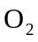at 1 atm and 273 K.
The decomposition of is shown as under:
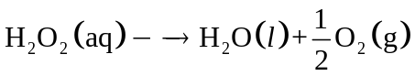
can acts as oxidizing as well as reducing agent, as oxidizing agent converted into 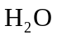and as reducing agent converted into , both cases it’s n-factor is 2.
Normality of solution 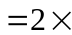Molarity of solution
33. What is the percentage strength (% w/V) of “11.2 V” ?
A) 1 M B) 2 M C) 5.6 M D) 11.2 M
34. 40 g 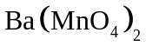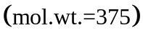sample containing some inert impurities in acidic medium is completely reacted with 125 mL of “33.6 V” of . What is the percentage purity of the sample?
A) 28.12% B) 70.31% C) 85% D) None of these
Paragraph for Question Nos. 35 to 36:
Consider the following series of reactions:
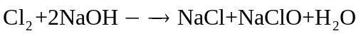
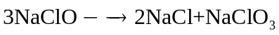
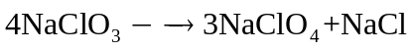
35. How much 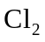is required to prepare 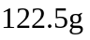of 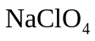by above sequencial reactions?
A) 284 g B) 213 g C) 142 g D) 71 g
36. How many mole of total NaCl formed by using 1 mole & other reagents in excess?
A) 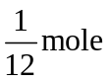 B) 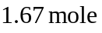 C) 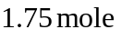 D) 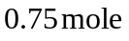
MATHEMATICS Max.Marks: 60
SECTION- I
(Maximum Marks : 24)
This section contains SIX (06) questions.
Each question has FOUR options for correct answer(s). ONE OR MORE THAN ONE of these four option(s) is (are) correct option(s).
For each question, choose the correct option(s) to answer the question.
Answer to each question will be evaluated according to the following marking scheme:
Full Marks : +4 If only (all) the correct option(s) is (are) chosen.
Partial Marks: +3 If all the four options are correct but ONLY three options are chosen.
Partial Marks: +2 If three or more options are correct but ONLY two options are chosen, both of which are correct options.
Partial Marks : +1 If two or more options are correct but ONLY one option is chosen and it is a correct option.
Zero Marks : 0 If none of the options is chosen (i.e. the question is unanswered).
Negative Marks: -2 In all other cases.
37. If S is the set of all real x such that 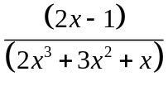is positive, then S contains
A) 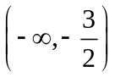 B) 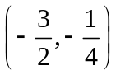 C) 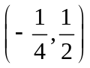 D) 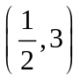
38. The sum of n terms of the series 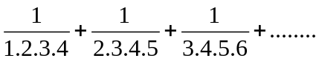is
A) 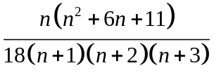 B) 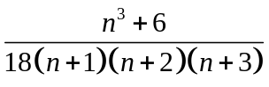
C) 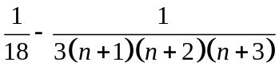 D) 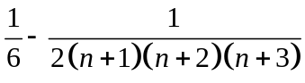
39. If a, b, c are in H.P. then
A) 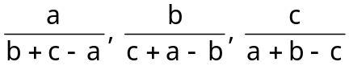 are in H.P.
B) 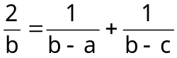 if a, b, c are distinct numbers
C) 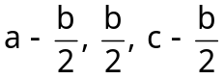 are in G.P.
D) 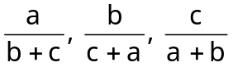 are in H.P.
40. If 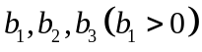are three successive terms of a GP with common ratio r for which the inequality 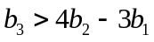holds is given by
A) 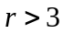 B) 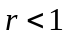 C) 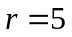 D) 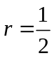
41. Let and are two positive real numbers. Suppose 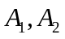are two arithmetic means, 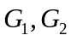are two geometric means and 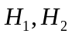are two harmonic means between and then which of the following is/are correct?
A) 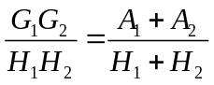 B) 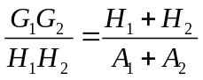
C) 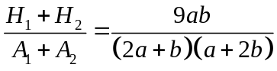 D) 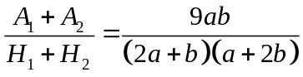
42. Let 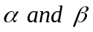 be the real roots of 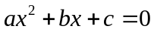.If 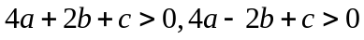and 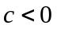,
then 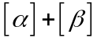can be:
A) -2 B) -1 C) 0 D) 1

SECTION - II
(Maximum Marks : 24)
This section contains EIGHT (08) questions. The answer to each question is a NUMERICAL VALUE
For each question, enter the correct numerical value (in decimal notation, truncated/rounded off to the second decimal place; e.g. 6.25, 7.00, -0.33, -.30, 30.27, -127.30) designated to enter the answer.
Answer to each question will be evaluated according to the following marking scheme:
Full Marks: +3 If ONLY the correct numerical value is entered as answer.
Zero Marks: 0 In all other cases.
43. The series of nature numbers are arranged as follow
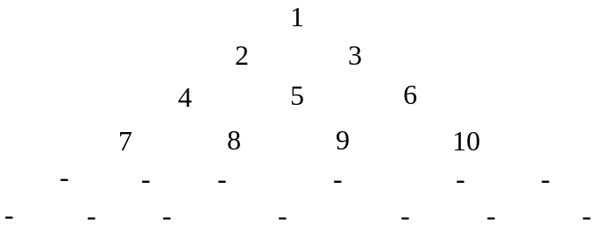
Then the sum of numbers in 20th row is
44. If the equations 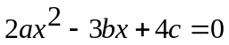and 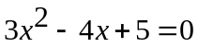have a common root , then 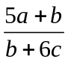is equal to 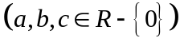
45. Let be the arithmetic mean and y,z be the two geometric means between aby two positive numbers, then the value of 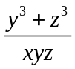 is
46. Largest integral value of ‘m’ for which the quadratic expression 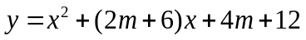 is always positive, 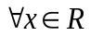, is
47. If 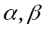 and be the roots of equation 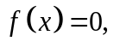 where 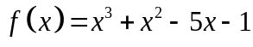 , then the value of 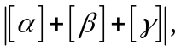 where  denotes the greatest integer function, is equal to
48. If 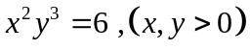, then the least value of 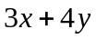is_________
49. The minimum value of the sum of numbers 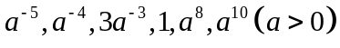is________
50. If the sum of an infinitely decreasing G.P. is equal to 4 and the sum of the cubes of its terms is 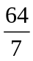, then 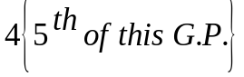is
Section – III
(COMPREHENSIN TYPE)
This section contains 2Paragraphs. Based on each paragraph, there are 2 questions. Each question has 4 options (A), (B), (C) and (D) for its answer, out of which ONLY ONE option can be correct.
Marking scheme: +3 for correct answer, 0 if not attempted and -1 in all other cases.

Paragraph for Question Nos. 51 to 52:
Let 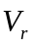denote first terms of an arithmetic progression whose first terms is and common difference is 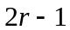. If 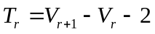, then
51. 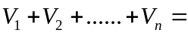
A) 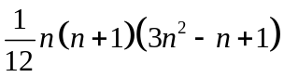 B) 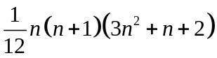
C) 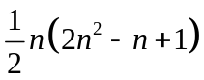 D) 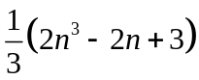
52. 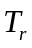is always
A) an odd number B) an even number
C) a prime number D) a composite number
Paragraph for Question Nos. 53 to 54:
Consider a rational function 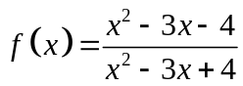and a quadratic function 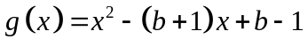, where b is a parameter
53. The sum of integers in the range of f(x) is
A) -5 B) -6 C) -9 D) -10
54. The largest natural number b satisfying 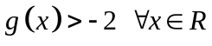is
A) 1 B) 2 C) 3 D) 4

Paper Setter : VSP-SARASWATHI BHAVAN N-120 (B)
Mathematics | Physics | Chemistry
Sri. V.V.SUBBA RAO | Sri. ANIL DEV | Sri. BALARAJU
9849022309 | 9849467034 | 9491676598

